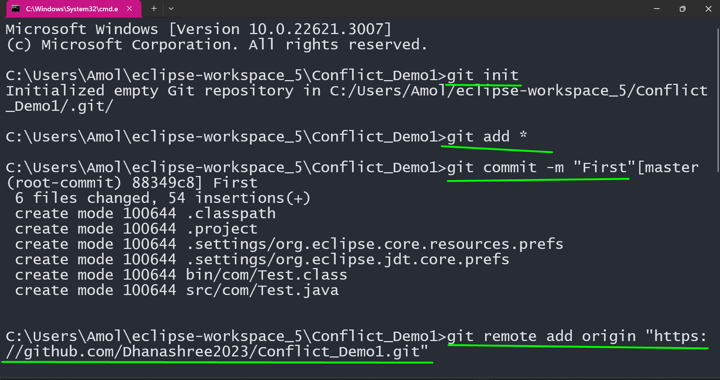

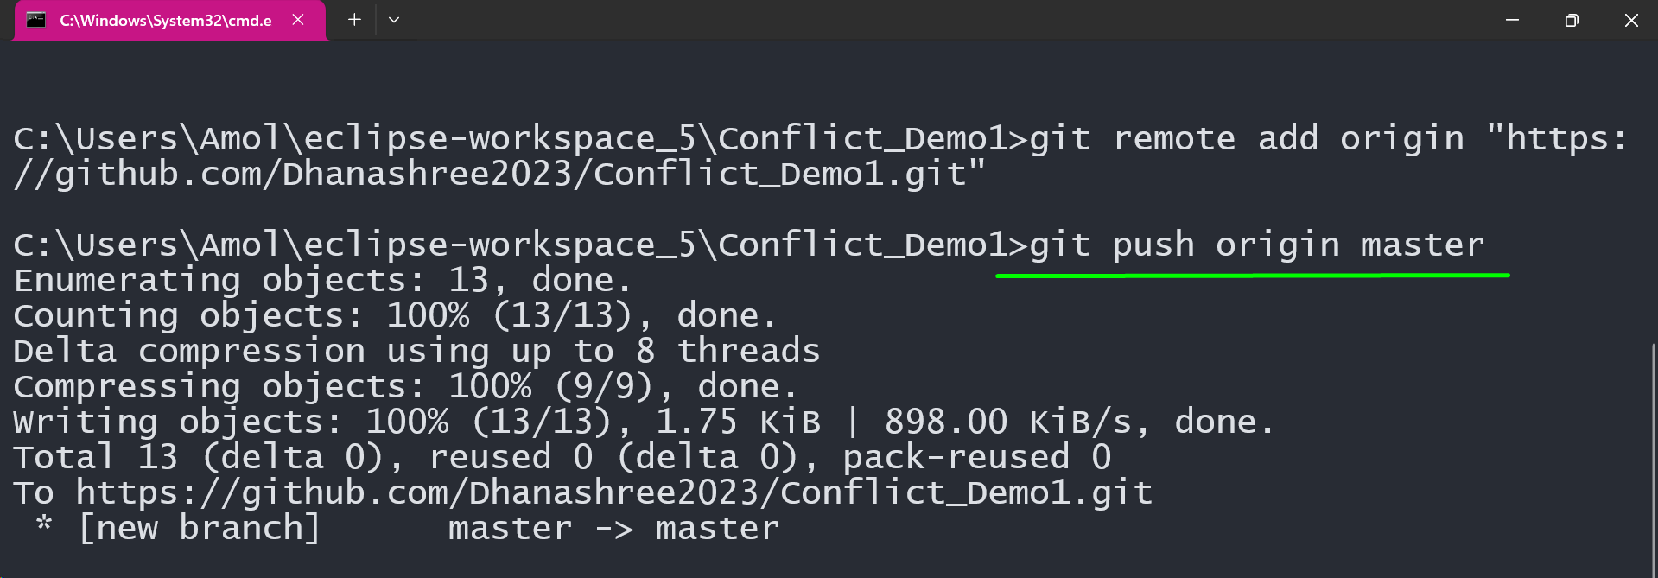

Both X and Y Developer having same project Code

System.***out***.println("Test Case 1");

Now x developer updated some code and pushed it

System.***out***.println("Test Case 1");

**int** i =0;

System.***out***.println("TestCase2");

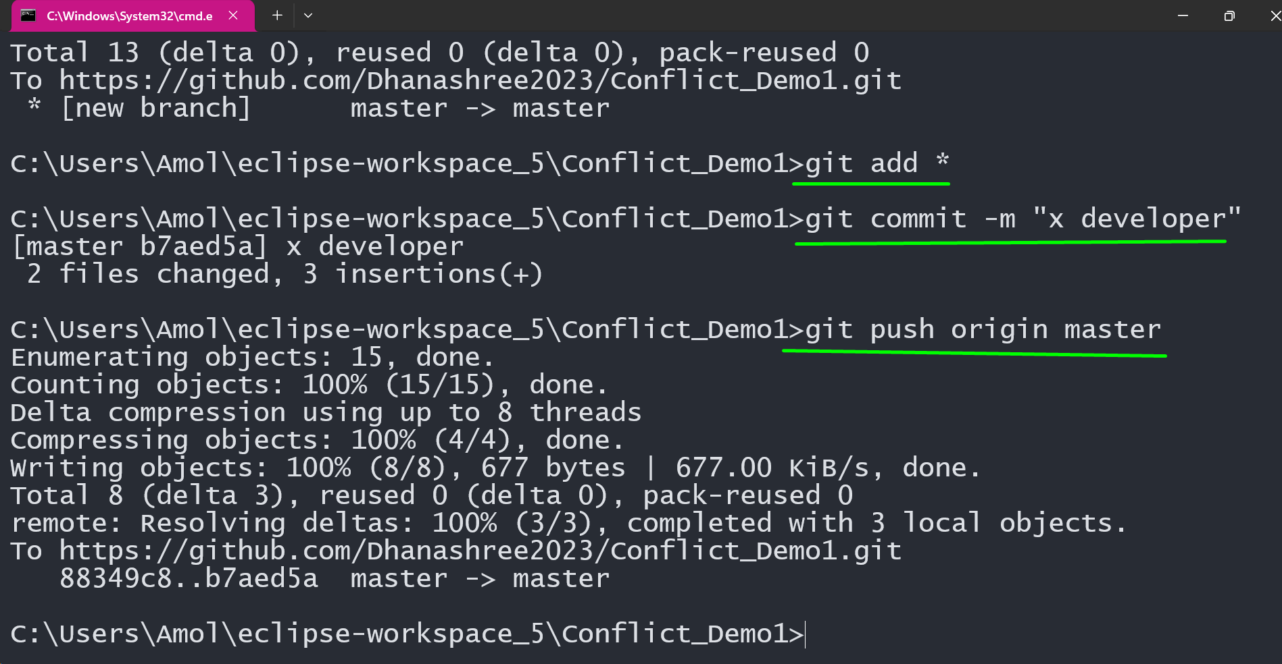

Y developer did not take updates and add some lines in same location

System.***out***.println("Test Case 1");

String m = "hghjg";

System.***out***.println("1111111111111");

And Y developer try to push the code in that case he will get the error

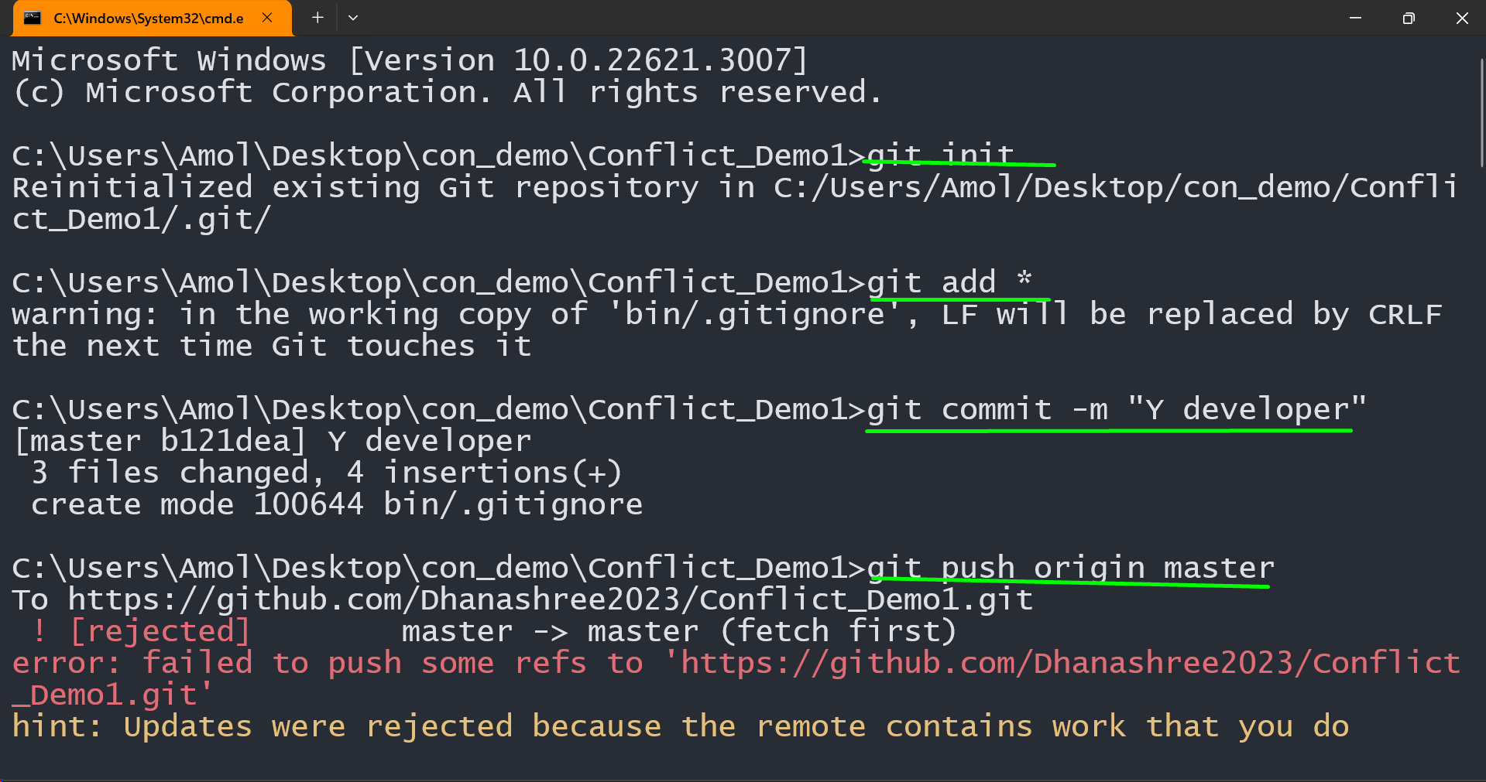

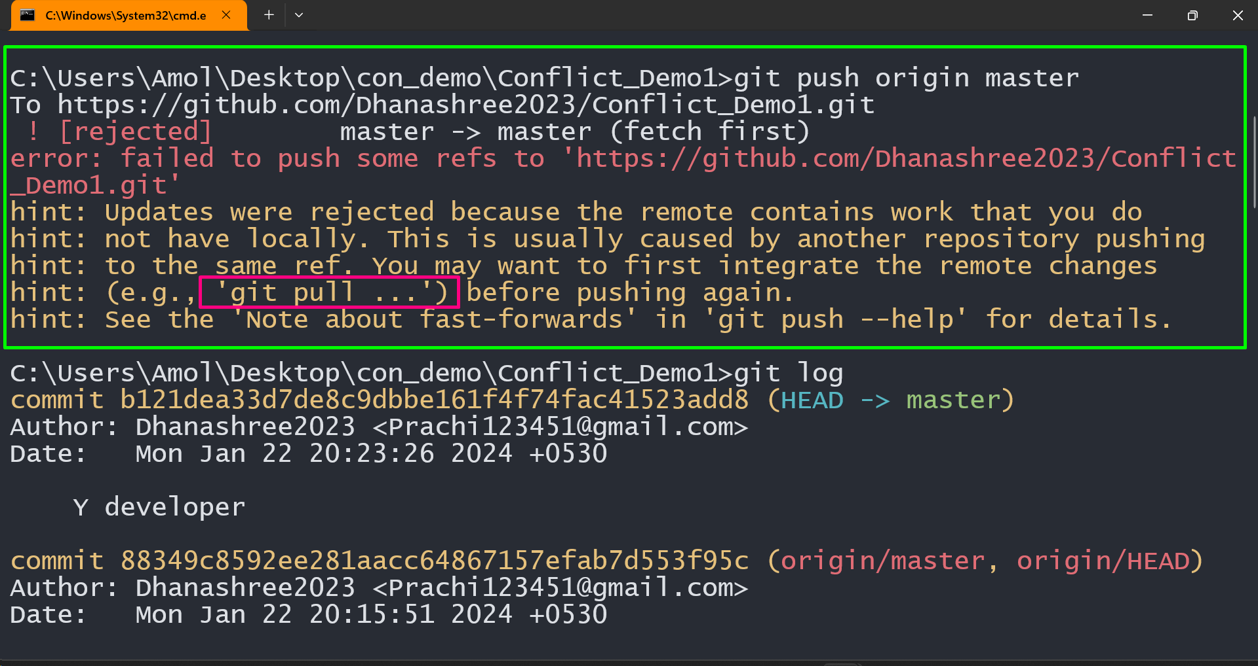

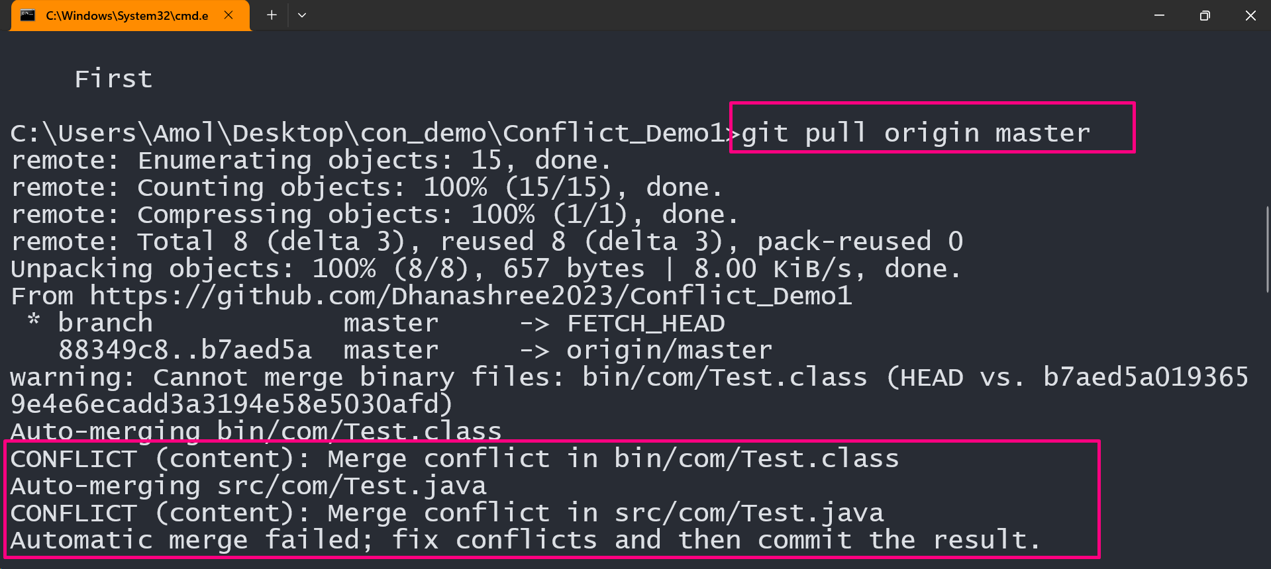

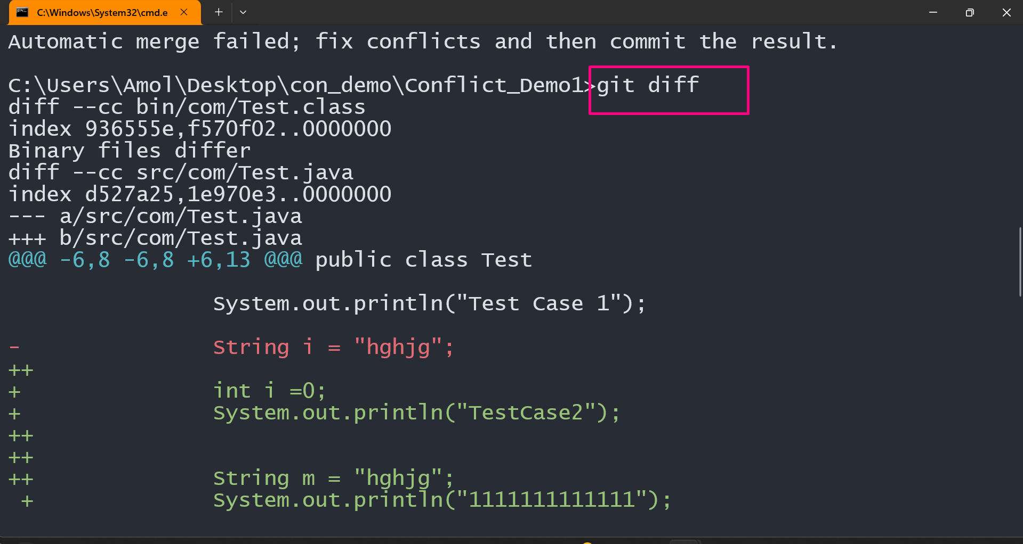

**Y Developer need to make necessary changes in File. Then Pushed the Code**

System.***out***.println("Test Case 1");

**int** i =0;

System.***out***.println("TestCase2");

String m = "hghjg";

System.***out***.println("1111111111111");

